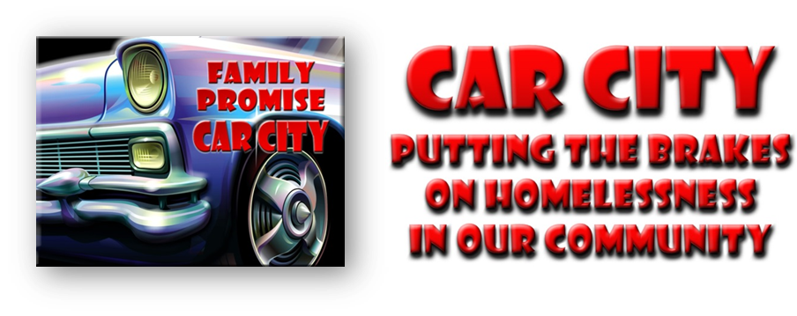

Car City Parking Citation Pledge Form

Family Promise of Greater Houston County
“Putting the Brakes on Homelessness in Our Community”

Car City Participant Name:

Sponsoring Organization:

Donor Name | Address | Phone | Pledge Amount | Pledge Collected
Total Pledges

FAMILY PROMISE OF GREATER HOUSTON COUNTY is a nonprofit network of interfaith organizations working together to end homelessness for children and their families. The Car City event is designed to raise awareness of homelessness and to raise funds to help families regain their independence. Family Promise is a 501(c)3 organization. All donations are tax deductible.

